Dé Luain | Dé Máirt | Dé Céadaoin | Déardaoin
Gaeilge:  - Litriú nua  - Amharcfocail nua  - Léitheoireacht – Mo Chlann | Gaeilge:  - Litriú nua  - Amharcfocail nua  - Léitheoireacht – Mo Chlann | Gaeilge:  - Litriú nua  - Amharcfocail nua  - Léitheoireacht – Mo Chlann | Gaeilge:  - Litriú nua  - Amharcfocail nua  - Léitheoireacht – Mo Chlann
Béarla  - New spellings  - New Tricky Words  - Reading – Rainbow Stage 2 Core Reader 4 The Time Capsule -Where Is Max pages 2-5 | Béarla  - New Spellings  - New Tricky Words  - Reading – Rainbow Stage 2 Core Reader 4 The Time Capsule -Where Is Max pages 6-10 | Béarla  - New Spellings  - New Tricky Words  - Reading – Rainbow Stage 2 Core Reader 4 The Time Capsule -Where Is Max pages 11-14 | Béarla  - New Spellings  - New Tricky Words  - Reading – Rainbow Stage 2 Core Reader 4 The Time Capsule -Where Is Max pages 15-18
Mata  - Táblaí na seachtaine | Mata  - Táblaí na seachtaine | Mata  - Táblaí na seachtaine | Mata  - Táblaí na seachtaine

Spellings Litriú
elf  self  selfish  shelf  myself  yourself  herself  himself  dirt  dirty  shirt  thirsty  drop  chop  shop | Tricky Words:  all  you  your  come  some  Amharcfocail:  seo  go  na  rith  maith | í  rí  ní  sí  bí  trí  arís  go dtí  níl  míle  Síle

5 + 0 = 5  agus nó móide  (and or plus)  cothrom le  (equal to) | 6 + 0 = 6
5 + 1 = 6 | 6 + 1 = 7
5 + 2 = 7 | 6 + 2 = 8
5 + 3 = 8 | 6 + 3 = 9
5 + 4 = 9 | 6 + 4 = 10
5 + 5 = 10 | 6 + 5 = 11
5 + 6 = 11 | 6 + 6 = 12
5 + 7 = 12 | 6 + 7 = 13
5 + 8 = 13 | 6 + 8 = 14
5 + 9 = 14 | 6 + 9 = 15
5 + 10 = 15 | 6 + 10 = 16

Úsáid an bosca 0-99 le cabhrú leat má ta tú i bponc!
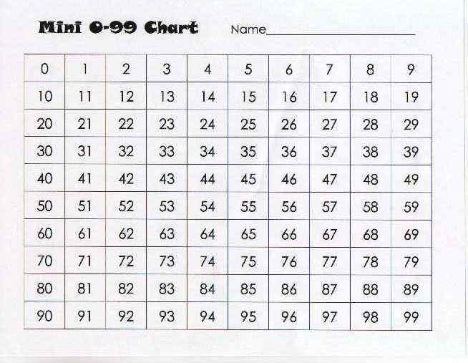
Use the 0-99 box if you get a bit stuck!

Seo leagan amach de thopaicí ginearálta a bheidh á phlé againn an tseachtain seo chughainn:
Here is a general outline of topics which we will discuss in class next week:
Gaeilge:
Téama ginearálta – an Fómhar agus na rudaí a tharlaíonn san Fhómhar (Oíche Shamhna, duilleoga ag titim de na crainn, ainmhithe agus nithe nádúrtha a fheicimid ag an am seo sionnach, gráinneog, boín Dé, cnó capaill, sméara dubha srl.)
General theme of the month – Autumn, and the things that happen during Autumn (Halloween, leaves falling from the trees, the animals and natural objects we may see at this time foxes, hedgehogs, lady birds, horse chestnuts, blackberries etc.)
Béarla:
General theme of the week – How people live (within verious cities, the jobs they have etc.)
Mata:
Oibríochtaí suimiú a chleachtadh níos mó agus dul siar ar dhealú // Pátrúin le huimhreacha // Siméadracht i gcruthanna agus sa timpeallacht
Operations continue practicing addiation and begin revision on subtraction // Creating patterns with numbers // Exploring symmetry in shapes and in the environment
OSPS (Oideachas Sóisialta, Pearsanta agus Sláinte) / SPHE (Social, Personal and Health Education):
Stay Safe programme topic What is bullying?

