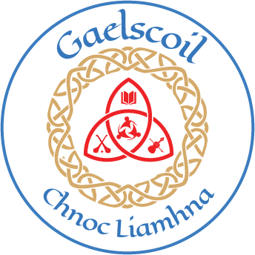
Gaelscoil Chnoc Liamhna
ANNUAL ADMISSION NOTICE
in respect of admissions to the 2024/2025 school year

Admission Policy and Application Form
A copy of the school’s Admission Policy and the Application Form for Admission for the 2024-25 is available as follows: –
To download at: www.gaelscoilchnocliamhna.ie
On request: By emailing runai@gaelscoilcl.com or by writing to:
Gaelscoil Chnoc Liamhna, Bóthar Chnoc Liamhna, Cnoc Liamhna, D16 F9W8

PART 1 - Admissions to the 2024/2025 school year

Application and Decision Dates for admission to 2024/2025
The following are the dates applicable for admission to Junior Infants

The school will commence accepting applications for admission on | 2/10/2023
The school shall cease accepting applications for admission on | 24/10/2023
The date by which applicants will be notified of the decision on their application is | 10/11/2023
The period within which applicants must confirm acceptance of an offer of admission is | 20/11/2023

Note: the school will consider and issue decisions on late applications in accordance with the school’s admission policy.
The offer may be withdrawn if the applicant does not accept the offer of admission
within the timeframe set out

Number of places being made available in 2024/2025

The number of places being made available in junior infants/first year is | 29

